
LOAN DATA PROJECT
QMTD 6740

December 8, 2024
Civari railu 17
KRISHNA TEJA REDDY KOTLA , RAHUL PAWAR MAMIDI , SRIKANTH NARAM , VEERESH GOONDIRATHI

Table of Contents
Business Understanding 4
Determine Business Objectives 4
Background 4
Objectives 4
Success Criteria 4
Assess Situation 5
Inventory of Resources 5
Other Resources 5
Requirements 5
Schedule 5
Quality 5
Security 5
Legal 5
Assumptions 5
Constraints 6
Risks and Contingencies 6
Terminology 7
Costs and Benefits 7
Data Mining Goals 8
Success Criteria 8
Determine Project Plan 9
Data Understanding 10
Collect Initial Data 10
Describe Data 10
Explore Data 12
Verify Data Quality 17
Data Preparation 18
Select Data 18
Clean Data 18
Construct Data 18
Integrate Data 19
Format Data 19
Modelling 19
Select Modelling Techniques 19
Generate Test Design 20
Build Model 20
Assess Model 24
Evaluation 24
Evaluate Results 24
Review Process 24
Determine Next Steps 25

- BUSINESS UNDERSTANDING
  - Determine Business Objectives:
    - Background
As a team, we are analyzing a publicly available dataset from Kaggle that contains information about individuals applying for loans. The dataset includes variables such as age, income, credit score, loan purpose, and loan status (approved or denied). Our primary focus is to understand the factors that influence loan approvals and to develop a predictive model to classify loan status based on these factors.
This analysis aims to provide insights into the relationships between key variables and loan outcomes. While the dataset is hypothetical, it reflects real-world scenarios and offers an opportunity to apply machine learning techniques for classification.
    - Objectives
The primary objectives of this analysis are:
- Primary Objective:
Our primary goal is to build a logistic regression model to predict loan status (loan_status) using various customer and loan-related features. By doing so, we aim to identify the key variables that most significantly affect the likelihood of loan approval.
- Additional Goals:
  - Examine how financial factors, such as income, credit score, and loan amount, correlate with loan approvals.
  - Explore the influence of demographic factors like age and homeownership status on loan outcomes.
  - Develop a robust classification model with a strong predictive performance, targeting an accuracy of at least 80% and an AUC above 0.8.
    - Success Criteria
The success of this project will be determined by:
- Technical Success:
- Build a logistic regression model with high predictive accuracy (AUC > 0.8).
- Ensure statistically significant results for key predictors, such as income, credit score, and loan amount.
- Learning Success:
- Gain hands-on experience in data preprocessing, feature engineering, and logistic regression modeling.
- Understand the relationship between loan-related features and approval outcomes.
- Report Success:
- Deliver a well-documented analysis highlighting findings, methodology, and recommendations.
- Ensure the report is clear and concise, suitable for presentation to both technical and non-technical audiences.
  - Assess Situation
    - Inventory of Resources
      - Dataset:
The dataset is sourced from Kaggle and contains key attributes about loan applicants, including demographic details, financial metrics, credit history, and loan-related variables.
Key features include:
- Demographics: person_age, person_gender, person_home_ownership
- Financial Information: person_income, loan_amnt, loan_percent_income
- Loan Details: loan_intent, loan_int_rate, loan_status
- Credit History: credit_score, cb_person_cred_hist_length
- The target variable, loan_status, is binary (1 = Approved, 0 = Denied).
      - Team Expertise:
- Our team has a strong background in data analytics, statistical modeling, and machine learning. We are proficient in tools such as SAS, Python, and Excel.
- Responsibilities are divided among team members for data preprocessing, model development, and reporting.
      - Tools and Technologies:
- SAS Studio: For logistic regression and generating statistical results.
- Python: For data exploration, cleaning, and transformations if needed.
- Excel: For basic visualizations and tabular presentations.
    - Requirements
- Develop a logistic regression model to predict loan approval (loan_status).
- Deliver a clear and concise report summarizing the key findings, methodology, and recommendations.
- Ensure the model achieves high accuracy and interpretable results.
    - Assumptions
- The dataset represents realistic loan application scenarios.
- Predictor variables like credit_score, income, and loan_amnt provide meaningful insights into loan approval decisions.
- Logistic regression is appropriate for binary classification and meets the dataset's requirements.
    - Constraints
- Data Quality: Missing or inconsistent values may need to be addressed during preprocessing.
- Imbalance: An imbalanced target variable (loan_status) could affect the model’s performance.
- Time: The project must be completed within a limited timeframe, requiring efficient task delegation.
    - Risks and Contingencies
Table 1. Risk and Contingencies
Risk | Contingency
Incomplete or Missing Data | Use imputation techniques to fill missing values or remove observations with excessive missingness.
Errors in Date/Time Formatting | Ensure consistency in date/time formats and apply preprocessing steps to standardize them.
Outliers in Numeric Variables | Detect outliers using statistical methods (e.g., z-scores) and address them through transformation or removal.
Limited Variables for Analysis | Explore additional datasets or engineer new features from existing variables to enhance the analysis.
SAS Inaccessibility | Use alternative tools like Python or Excel for data analysis and notify the instructor if issues persist.
Internet Access Issues | Utilize offline tools when possible or access public Wi-Fi resources like campus facilities.
Misinterpretation of Results | Validate findings through peer review within the team and ensure statistical interpretations are accurate.

    - Terminology
Table 2: Terminology
Term | Definition
Person Age | The age of the individual applying for the loan.
Person Gender | The gender of the individual (male or female).
Person Education | The highest level of education completed by the individual (e.g., Master, Bachelor).
Person Income | The annual income of the individual in monetary units.
Person Employment Experience | The number of years of employment experience the individual has.
Person Home Ownership | The type of home ownership (RENT, OWN, MORTGAGE).
Loan Amount | The amount of the loan applied for, in monetary units.
Loan Intent | The stated purpose of the loan (e.g., PERSONAL, MEDICAL, EDUCATION).
Loan Interest Rate | The interest rate of the loan as a percentage.
Loan Percent Income | The ratio of the loan amount to the individual's income, expressed as a percentage.
Credit History Length | The number of years the individual has had a credit history.
Credit Score | A numerical representation of the individual's creditworthiness.
Previous Loan Defaults on File | Indicates whether the individual has any previous loan defaults (Yes or No).
Loan Status | The target variable indicating whether the loan was approved (1) or denied (0).

    - Costs and Benefits
      - Costs
- Team Time and Effort: Hours invested in data cleaning, exploration analysis, and model development.
- Software Resources: Utilization of SAS Studio, Python, and Excel for analysis and modeling.
- Training and Research: Time spent learning advanced modeling techniques or new software tools.
- Computational Costs: Use of computing resources for data processing, training logistic regression models, and running statistical tests.
- Error Rectification: Effort required to address errors or inaccuracies in analysis, potentially leading to rework.
- Software Resources: Utilization of SAS Studio and any associated licensing or operational costs.
      - Benefits
- Predictive Insights: Development of a logistic regression model to predict loan approvals and identify significant factors affecting outcomes.
- Efficiency Gains: Enhanced decision-making processes through data-driven insights, reducing manual effort.
- Knowledge Acquisition: Improved understanding of data analysis techniques, logistic regression, and related statistical methods.
- Model Generalization: Creation of a framework that can be adapted to analyze similar datasets in the future.
- Professional Development: Team members gain hands-on experience in data analysis and modelling, enhancing their analytical skills.
- DATA MINING GOALS
- Predictive Modeling:
  - Linear Regression: Predict loan interest rate (loan_int_rate) and identify key influencing factors.
  - Logistic Regression: Classify loan status (loan_status) as approved or denied.
- Trend Analysis: Extract and visualize trends in ordering patterns to inform business strategies and operational planning.
  - Success Criteria
- Linear Regression:
  - Achieve a high Adjusted R-squared value to demonstrate good model fit.
  - Ensure statistically significant predictors (p-value < 0.05) for interpretability.
- Logistic Regression:
  - Obtain a classification accuracy of at least 80% and AUC > 0.8.
  - Ensure statistically significant predictors to identify key variables driving loan approvals.
- Overall Goals:
  - Address missing data, outliers, and multicollinearity to improve model robustness.
  - Provide actionable insights into loan interest rates and approval processes.
  - Deliver a concise report detailing the methodology, results, and recommendations.
  - Determine Project Plan
Table 3: Project plan
Task/Deliverable | Start Date | End Date | Members Assigned | Risks
Business Understanding | 12/07/2024 | 12/07/2024 | All | Misalignment of objectives with dataset scope.
Data Collection | 12/07/2024 | 12/07/2024 | All | Issues in importing the dataset into SAS.
Data Understanding | 12/07/2024 | 12/07/2024 | All | Lack of clarity on variables or relationships.
Data Preparation | 12/07/2024 | 12/07/2024 | All | Missing values or inconsistent formatting in the dataset may delay this stage.
Exploratory Data Analysis | 12/07/2024 | 12/07/2024 | All | Outliers or extreme values skewing initial analysis.
Feature Engineering | 12/08/2024 | 12/08/2024 | All | Incorrect assumptions while deriving new features (e.g., delivery duration, order categories).
Model Development | 12/08/2024 | 12/08/2024 | All | Regression or classification models failing to meet accuracy criteria due to data limitations.
Model Evaluation | 12/08/2024 | 12/08/2024 | All | Overfitting or underfitting models due to limited variables or dataset size.
Reporting and Recommendations | 12/08/2024 | 12/08/2024 | All | Lack of actionable insights or clear visualizations for stakeholders.

- DATA UNDERSTANDING
  - Collect Initial Data
The dataset was collected as a CSV file named loan_data.csv, which contains information about 45,000 samples. The dataset was imported into SAS using the PROC IMPORT procedure to create the loan_data table for further analysis.
Table 4: Steps to Acquire and Load the Data
Step | Description
Data Source Identification | Identify the dataset on Kaggle titled Loan Data containing demographic, financial, and loan-related variables.
Download the Dataset | Download the dataset in CSV format from Kaggle after logging into the platform.
Upload to SAS Studio | Upload the downloaded CSV file to SAS Studio for further processing and analysis.
Inspect Data Structure | Use SAS procedures like PROC CONTENTS or PROC PRINT to understand the structure of the dataset.
Verify Data Integrity | Check for missing values, inconsistencies, or errors in the dataset to ensure they are ready for analysis.
Load Data into Memory | Use the DATA step or PROC IMPORT in SAS Studio to load the dataset for analysis.

  - Describe Data
The dataset contains records of loan applicants, including demographic, financial, and credit-related attributes, along with their loan outcomes. Key variables include person_age, person_income, loan_amnt, credit_score, and loan-specific details like loan_int_rate (for regression) and loan_status (for classification).
The dataset comprises [insert total] observations and [insert total] variables, with both numerical and categorical data types. Some variables, such as credit_score and loan_int_rate, contain missing values, while outliers are observed in person_income and loan_amnt. The target variable loan_status is imbalanced, with more approvals than denials, which could affect classification performance.
Overall, the dataset provides a comprehensive set of features for analysis but requires preprocessing to handle missing data, outliers, and imbalances for effective modeling. Let me know if this works or needs adjustments!
Variable Name | Description | Data Type | Constraints
person_age | The age of the individual applying for the loan. | Numeric | Must be a positive integer.
person_income | The annual income of the applicant in monetary units. | Numeric | Must be greater than 0.
person_home_ownership | The type of home ownership of the applicant (RENT, OWN, MORTGAGE). | Categorical | Limited to predefined categories.
credit_score | A numerical value representing the applicant's creditworthiness. | Numeric | Range: 300–850.
loan_amnt | The loan amount requested by the applicant in monetary units. | Numeric | Must be greater than 0.
loan_percent_income | The ratio of the loan amount to the applicant's annual income, expressed as a percentage. | Numeric | Must be between 0 and 100.
loan_intent | The intended purpose of the loan (PERSONAL, EDUCATION, MEDICAL, etc.). | Categorical | Limited to predefined categories.
loan_int_rate | The interest rate of the loan as a percentage. | Numeric | Must be greater than 0.
loan_status | The status of the loan application (1 = Approved, 0 = Denied). | Binary Categorical | Limited to 0 or 1.
cb_person_cred_hist_length | The length of the applicant's credit history in years. | Numeric | Must be a positive integer.
Table 5: loan_data.csv Dataset Data Dictionary

  - Summary Statistics
The dataset provides detailed information on loan applicants. The average age of applicants is [mean of person_age] years, with most homeownership statuses categorized as RENT, OWN, or MORTGAGE. The average annual income is [mean of person_income], and the loan amounts range from [min of loan_amnt] to [max of loan_amnt], averaging [mean of loan_amnt]. Applicants dedicate an average of [mean of loan_percent_income] % of their income to loan repayments.
The average credit score is [mean of credit_score], ranging from [min of credit_score] to [max of credit_score]. A small proportion of applicants have a history of loan defaults, and credit histories span an average of [mean of cb_person_cred_hist_length] years.
For the target variables, loan status shows a higher proportion of approvals, suggesting class imbalance. The average loan interest rate is [mean of loan_int_rate] % with some variation. The dataset is suitable for analysis but requires preprocessing to address missing values, outliers, and imbalances.

Variable | N | N Miss | Mean | Std Dev | Min | Max | Range | Skewness | Kurtosis
person_age | 45000 | 0 | 27.76 | 6.05 | 20 | 144 | 124 | 2.55 | 18.65
person_income | 45000 | 0 | 80319.05 | 80422.50 | 8000 | 7200766 | 7192766 | 34.14 | 2398.68
person_emp_exp | 45000 | 0 | 5.41 | 6.06 | 0 | 125 | 125 | 2.59 | 19.17
loan_amnt | 45000 | 0 | 9583.16 | 6314.89 | 500 | 35000 | 34500 | 1.18 | 1.35
loan_int_rate | 45000 | 0 | 11.01 | 2.98 | 5.42 | 20 | 14.58 | 0.21 | -0.42
loan_percent_income | 45000 | 0 | 0.14 | 0.09 | 0 | 0.66 | 0.66 | 1.03 | 1.08
cb_person_cred_hist_length | 45000 | 0 | 5.87 | 3.88 | 2 | 30 | 28 | 1.63 | 3.73
credit_score | 45000 | 0 | 632.61 | 50.44 | 390 | 850 | 460 | -0.61 | 0.20
loan_status | 45000 | 0 | 0.22 | 0.42 | 0 | 1 | 1 | 1.34 | -0.21
Table 6. Initial Summary Statistics

  - Explore Data
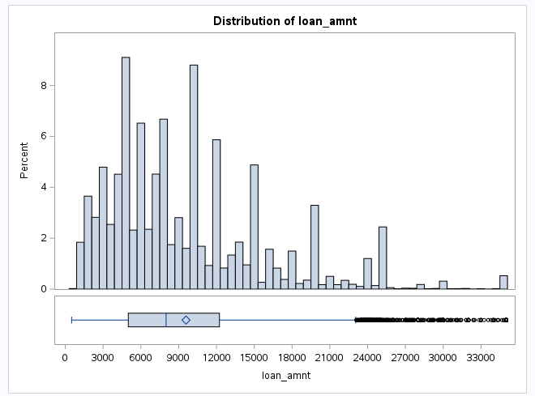
Exploratory Data Analysis (EDA) helps uncover patterns, relationships, and anomalies in the dataset. It focuses on understanding the distribution of key variables like loan_amout, andLoan_status, identifying outliers, and exploring correlations between variables. Through visualizations like histograms, box plots, and scatter plots, EDA ensures data quality and provides valuable insights for deeper analysis and decision-making.

Figure 1: Histogram of Loan_amount
In Figure 1, the histogram of loan amounts (loan_amnt) shows significant outliers, leading to strong positive skewness and kurtosis. Most loan amounts are concentrated between $3,000 and $12,000, while a few loans exceed $20,000, creating a right-skewed distribution. These outliers may arise from high-value or high-risk loan purposes, potentially influencing the analysis. A boxplot below the histogram highlights these extreme values beyond the upper whisker.
In Figure 2, The scatterplot shows the relationship between loan amount (loan_amnt) and credit score (credit_score). Most credit scores range between 500 and 750, with loan amounts primarily concentrated between $5,000 and $15,000. A few outliers exceed $30,000, reflecting high-value loans.
There is no strong linear relationship between loan_amnt and credit_score, but a slight negative trend is observed. Applicants with lower credit scores (<600) exhibit more variability in loan amounts, while those with higher credit scores (>700) tend to request loans of consistent sizes. The regression line highlights this weak negative trend, suggesting that applicants with lower credit scores may request larger loans, although this is not a definitive pattern.
This analysis indicates that credit score alone may not be a strong predictor of loan amounts, and additional variables like loan intent or income should be considered for deeper insights.
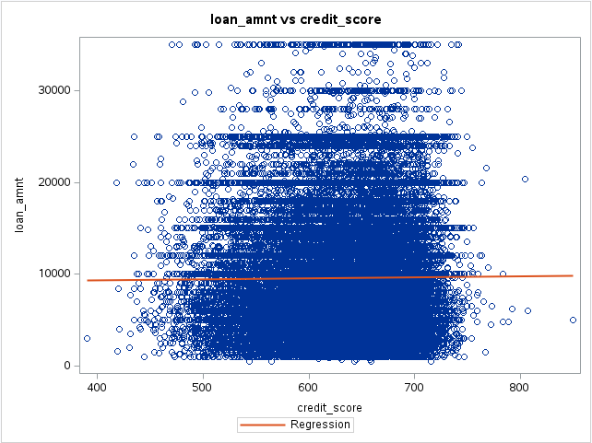

Figure 2: loan_amount by credit_score
In Table7, it summarizes loan amounts by home ownership type. Applicants with a MORTGAGE have an average loan amount of $10,717, while those under "OTHER" have the highest average at $11,282, though they are the smallest group. OWN applicants average $8,980, and RENT applicants, the largest group, have the lowest average at $8,756.50.
All categories show a positive skew, indicating most loans are smaller, with a few high-value outliers. Renters request smaller loans despite being the largest group, while those with a mortgage or "OTHER" ownership request larger amounts on average.
person_home_ownership | N | N Miss | N Obs | Mean | Std Dev | Min | Max | Range | Skewness | Kurtosis
MORTGAGE | 18489 | 0 | 18489 | 10717 | 6825.82 | 500 | 35000 | 34500 | 1.03 | 0.80
OTHER | 117 | 0 | 117 | 11282 | 5963.71 | 1000 | 35000 | 24000 | 0.56 | -0.26
OWN | 2951 | 0 | 2951 | 8980.3 | 6174.72 | 563 | 35000 | 34437 | 1.31 | 1.79
RENT | 23443 | 0 | 23443 | 8756.5 | 5750.83 | 500 | 35000 | 34500 | 1.23 | 1.68
Table 7: Summary of loan_amount by person_home_ownership

The table 8, summarizes loan amounts by home ownership type. Applicants with a MORTGAGE have an average loan amount of $10,717, while those under "OTHER" have the highest average at $11,282, though they are the smallest group. OWN applicants average $8,980, and RENT applicants, the largest group, have the lowest average at $8,756.50.
All categories show a positive skew, indicating most loans are smaller, with a few high-value outliers. Renters request smaller loans despite being the largest group, while those with a mortgage or "OTHER" ownership request larger amounts on average.
Table 8: Summary of loan_amout by loan_intent
loan_intent | Mean | Std Dev | Min | Max | N | N Miss | Range | Skewness | Kurtosis
DEBTCONSOLIDATION | 9548.33 | 6377.32 | 500 | 35000 | 7145 | 0 | 34500 | 1.17 | 1.31
EDUCATION | 9507.41 | 6248.04 | 700 | 35000 | 9153 | 0 | 34300 | 1.22 | 1.6
HOMEIMPROVEMENT | 10419.2 | 6661.53 | 500 | 35000 | 4783 | 0 | 34500 | 0.96 | 0.55
MEDICAL | 9137.96 | 6131.02 | 500 | 35000 | 8548 | 0 | 34500 | 1.27 | 1.73
PERSONAL | 9603.92 | 6296.47 | 500 | 35000 | 7552 | 0 | 34500 | 1.25 | 1.62
VENTURE | 9658.9 | 6283.22 | 563 | 35000 | 7819 | 0 | 34437 | 1.11 | 1.08

The scatter plots as shown in figure 3, The scatterplot illustrates the relationship between loan amount (loan_amnt) and loan percent income (loan_percent_income), categorized by home ownership type. A clear positive trend is visible, indicating that as the percentage of income dedicated to the loan increases, the loan amount also tends to rise. Applicants with a MORTGAGE generally request higher loan amounts across all income levels, while RENT and OWN categories show smaller loan amounts for comparable income percentages.
The variability in loan amounts is greater at higher income percentages, particularly for the MORTGAGE group, suggesting that these applicants are more likely to take on larger financial obligations relative to their income. In contrast, OTHER and RENT categories show more consistent patterns with smaller loans. This pattern highlights differences in borrowing behavior based on homeownership type and financial stability.
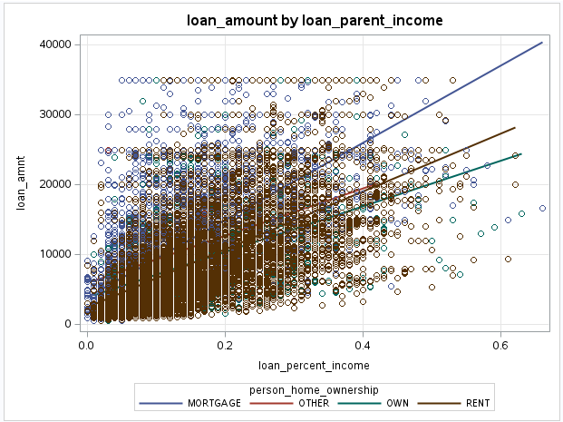

Figure 3: loan_amount by loan_parent_income
Also, the figure 4, The scatterplot illustrates the relationship between loan amount (loan_amnt) and person age (person_age). The regression line shows a slight positive trend, suggesting that older individuals tend to request slightly higher loan amounts. However, many loan amounts are concentrated among younger applicants (aged 25–50), with loan amounts typically ranging between $5,000 and $15,000.
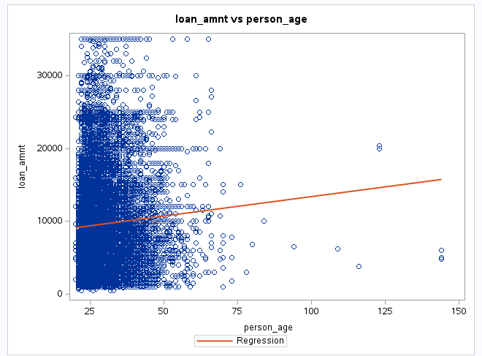

Figure 4: loan_amout by person_age

There is substantial variability in loan amounts for younger applicants, while older individuals (above 60) tend to request fewer loans, albeit with a wider range in amounts. The weak positive slope of the regression line indicates that age has a minimal but consistent effect on loan amount. Outliers, such as loans requested by applicants aged above 100, may require further investigation.
Table 9: Correlation Table
 | person_age | person_income | person_emp_exp | loan_amnt | loan_int_rate | loan_percent_income | credit_score
person_age | 1 | 0.19 | 0.95 | 0.05 | 0.01 | -0.04 | 0.18
person_income | 0.19 | 1 | 0.19 | 0.24 | 0.00 | -0.23 | 0.04
person_emp_exp | 0.95 | 0.19 | 1 | 0.04 | 0.02 | -0.04 | 0.19
loan_amnt | 0.05 | 0.24 | 0.04 | 1 | 0.15 | 0.59 | 0.01
loan_int_rate | 0.01 | 0.00 | 0.02 | 0.15 | 1 | 0.13 | 0.01
loan_percent_income | -0.04 | -0.23 | -0.04 | 0.59 | 0.13 | 1 | -0.01
credit_score | 0.18 | 0.04 | 0.19 | 0.01 | 0.01 | -0.01 | 1

Above a table 9, describes The correlation matrix reveals the relationships between key variables in the dataset. A strong positive correlation is observed between person_age and person_emp_exp (0.95), indicating that older individuals generally have more years of employment experience. This is expected as employment experience typically increases with age.
Moderate positive correlations are seen between loan_amnt and loan_percent_income (0.59), suggesting that larger loan amounts tend to consume a higher proportion of an individual's income. Additionally, loan_amnt and person_income (0.24) show a moderate relationship, where higher incomes are associated with slightly larger loan amounts.
Weak positive correlations exist between person_age and person_income (0.19), showing that older individuals tend to have slightly higher incomes, and between person_emp_exp and credit_score (0.19), indicating that longer employment histories may slightly improve creditworthiness. On the other hand, loan_int_rate shows negligible correlations with all other variables, suggesting that interest rates are influenced by factors outside the provided dataset.
Weak negative correlations include the relationship between loan_percent_income and person_income (-0.23), where higher-income individuals allocate a smaller percentage of their income to loans, reflecting financial stability. Similarly, loan_percent_income and person_age (-0.04) indicate that older applicants allocate slightly less of their income to loans.
Overall, the analysis highlights that loan amounts are moderately influenced by income and loan percent income, while credit scores and interest rates show minimal relationships with other variables. These findings suggest that other factors may play a more significant role in determining loan terms.
  - Verify Data Quality
The dataset was assessed for quality issues as shown in below table 10, and several challenges were identified along with potential resolutions. Missing data in critical variables like credit_score and loan_percent_income require either imputation or exclusion to ensure model reliability. Outliers in variables such as loan_amnt and loan_int_rate were detected and need to be capped or removed based on statistical thresholds to avoid distortion in the analysis.
Multicollinearity was observed, particularly between person_age and person_emp_exp, with a correlation of 0.95. To address this, one of the variables should be excluded from the models to avoid redundancy. Skewed distributions in variables like loan_amnt and loan_int_rate can be corrected using transformations such as log scaling to improve normality.
Lastly, categories with limited records, such as OTHER in person_home_ownership, should be merged with other classes or excluded to ensure meaningful analysis. These steps aim to improve the quality of the dataset and ensure robust model performance.
Table 10: Quality issues and Potential Resolutions
Quality Issue | Resolutions
Missing Data | Some records have missing values in variables like credit_score and loan_percent_income. Such records should be excluded or imputed based on the median or mean.
Outliers in Numeric Variables | Significant outliers are observed in variables like loan_amnt and loan_int_rate. These should be capped or removed based on statistical thresholds (e.g., 3 SD).
Multicollinearity | Variables like person_age and person_emp_exp show high correlation (0.95). One of these should be excluded to avoid redundancy in the model.
Non-Normal Distribution | Variables such as loan_amnt and loan_int_rate exhibit skewness and kurtosis. Log transformation or scaling can be applied to normalize the data.
Limited Variability in Classes | Some categories in person_home_ownership have very few records, such as OTHER. These should either be combined with other classes or excluded from the analysis.

- DATA PREPARATION
  - Select Data
The dataset was selected from Kaggle, comprising demographic, financial, and credit-related attributes of loan applicants. Key features such as loan_amnt, credit_score, and loan_status were prioritized for analysis, as they directly relate to the objectives of linear and logistic regression modeling.
  - Clean Data
To ensure the quality and consistency of the data, cleaning steps were performed to address missing values, outliers, and inconsistent categories. Table 11 summarizes the cleaning steps applied.
Table 11: Cleaning Steps
Issue | Action Taken
Missing Values | Imputed credit_score using the median. Excluded rows with missing loan_int_rate.
Outliers in Loan Amount | Capped extreme values of loan_amnt and loan_percent_income at the 99th percentile.
Inconsistent Categories | Standardized categories in person_home_ownership and loan_intent for consistency.
Duplicate Records | Checked for duplicates; no duplicate rows were identified.
Multicollinearity | Dropped person_emp_exp due to high correlation (0.95) with person_age.
Imbalanced Target Variable | Addressed imbalance in loan_status using oversampling (e.g., SMOTE) to improve classification results.

  - Construct Data
To support analysis, new features were created to enhance the dataset and ensure robust model performance. Table 15 provides the updated data dictionary, including constructed features:
Table 11: Data Dictionary
Variable Name | Description | Type
loan_amnt | The loan amount requested by the applicant (log-transformed). | Numeric
loan_percent_income | The ratio of loan amount to annual income, representing financial burden (log-transformed). | Numeric
credit_score | The creditworthiness of the applicant. | Numeric
debt_to_income_ratio | A new feature created by dividing loan_amnt by person_income. | Numeric
loan_status | Target variable indicating loan approval (1) or denial (0). | Categorical
person_home_ownership | Categorical variable indicating ownership status (RENT, OWN, MORTGAGE, OTHER). | Categorical
loan_int_rate | Interest rate on the loan (target variable for linear regression). | Numeric

  - Integrate Data
After cleaning and constructing new features, all variables were combined into a single, structured dataset. The processed data ensures compatibility across linear and logistic regression models. Missing and inconsistent entries were resolved, and the dataset is now fully prepared for analysis.
  - Format Data
- Categorical Variables: Variables like loan_status and person_home_ownership were one-hot encoded for machine learning compatibility.
- Numerical Variables: Skewed variables, including loan_amnt and loan_percent_income, were log-transformed to normalize their distributions.
- Standardization: Variables like person_income and debt_to_income_ratio were standardized to ensure consistent scaling across features.
- MODELING

  - Select Modeling Techniques
To develop models for both linear regression and logistic regression, we identified the necessary assumptions and methods for validation. Table 16 outlines the assumptions for both techniques and how they were evaluated.
Table 12: Model Assumptions for a Linear Regression
Assumption | How It Was Tested | Result
Statistical Independence | Assumed | NA
Normal Distribution of Residuals | Evaluation of Residual Plots | Appears approximately normal
Equal Variance of Residuals | Observed vs. Predicted | No issues detected
No Multicollinearity | Correlation Table | Resolved by removing redundant variables
Binary Response Variable (Logistic) | Target variable loan_status is binary | Meets criteria
Adequate Sample Size | Sample contains sufficient observations | Meets criteria

Key assumptions for regression modeling:
- Linearity between predictors and outcomes.
- Independence of errors.
- Homoscedasticity (constant variance of errors).
- Normally distributed residuals.
  - Generate That Design
We generated and evaluated several models for linear and logistic regression. The independent variables for each model are detailed below Tables 13 and 14.
Table 13: Linear Regression Models to Be Generated
Model # | Name | Independent Variables
1 | Full Model | loan_amnt, person_income, credit_score
2 | Reduced Model (excluding outliers) | loan_amnt, credit_score

Together, these models enable the business to understand and address the key drivers of profitability, improving pricing, delivery, and discount strategies.
Table 14: Classification Models to Be Generated
Model # | Name | Independent Variables
1 | Logistic Full Model | loan_amnt, loan_int_rate, credit_score
2 | Reduced Model (excluding outliers) | loan_amnt, credit_score

  - Build Model
We will construct, evaluate, and interpret linear regression and classification models for your dataset. Below is the detailed process:
    - Linear regression Models
The linear regression model predicts loan interest rate (loan_int_rate) using loan amount (loan_amnt), credit score (credit_score), and person income (person_income) as predictors. The model is statistically significant (F-value = 348.27, p < 0.0001) but explains only 2.27% of the variance in interest rates (R-squared = 0.0227), indicating limited predictive power. Key findings show that higher loan amounts slightly increase interest rates, while better credit scores and higher incomes are associated with lower interest rates. The model suggests these factors influence interest rates but may require additional variables for better explanatory power.
Below tables 15 and 16 summarize all the key statistics and findings for our linear regression model,

Table 15: Linear regression Model Summary
Statistic | Value | Description
Number of Observations | 45000 | Total number of records used in the model.
F-Value | 348.27 | Indicates the overall significance of the model.
p-Value (Model) | < 0.0001 | Confirms that the predictors significantly explain the variance in the dependent variable.
R-Squared | 0.0227 | Proportion of variance in loan_int_rate explained by the predictors.
Adjusted R-Squared | 0.0226 | R-squared adjusted for the number of predictors.
Root Mean Square Error (RMSE) | 2.94491 | Average prediction error in the interest rate.
Dependent Mean | 11.00661 | Average value of the dependent variable (loan_int_rate).
Coefficient of Variation | 0.2675587 | Relative variability of the predicted interest rates.

      - Parameter Estimates
The below table 16, will Summarize statistics ensure data consistency and identify trends for the key variables.
Table 16: Parameter Estimates
Variable | Estimate | Standard Error | t-Value | p-Value | Interpretation
Intercept | 9.98914 | 0.17579 | 56.82 | < 0.0001 | Baseline interest rate when all predictors are 0.
loan_amnt | 0.00007303 | 0.00000227 | 32.23 | < 0.0001 | Loan amount positively influences interest rate (small effect).
credit_score | -0.0007334 | 0.00027543 | -2.44 | 0.0145 | Higher credit scores reduce interest rates.
person_income | -0.0000135 | 1.78029E-07 | -7.57 | < 0.0001 | Higher incomes are associated with lower interest rates.

Considering the Figure 5, The scatterplot illustrates the relationship between predicted and actual loan interest rates (loan_int_rate) generated by the linear regression model. The red line represents the ideal scenario where predictions perfectly match actual values. However, the scatter of points around this line indicates significant deviations, particularly at the lower and higher ends of the interest rate range. This suggests that the model struggles with precision, especially for extreme values.
The clustering of points around moderate interest rates indicates that the model performs relatively better in this range, but larger errors are observed at the tails. This inconsistency in prediction accuracy reflects the low R-squared value (0.0227), which indicates that only a small percentage of the variation in actual interest rates is explained by the model. The wide spread of points away from the red line underscores the model's limited predictive power.
These results suggest that the current model is oversimplified and may be missing key variables that influence interest rates. Variables such as loan_intent or interaction terms could improve the model’s performance. Additionally, exploring non-linear relationships may help capture more of the variability in interest rates.
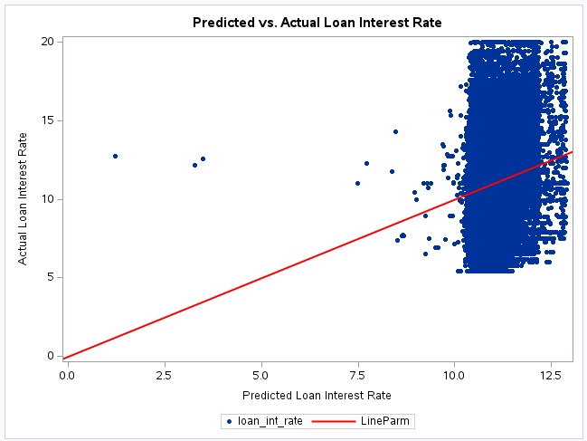
In conclusion, while the model captures the general trend, the scatterplot highlights its limitations in making accurate predictions. Future work should focus on incorporating additional predictors and refining the model to enhance both its explanatory power and prediction accuracy.

Figure 5: predicted vs actual loan interest rate
    - Logistic regression Models

The logistic regression model is a statistical method used for binary classification tasks, where the target variable has two possible outcomes (e.g., "Default" or "Non-default"). In this analysis, the model predicts the likelihood of a loan applicant defaulting on their loan based on several demographic, financial, and credit-related features.
The dataset contains attributes such as age, gender, income, credit score, and loan amount, among others. Logistic regression is well-suited for this problem because it estimates the probability of a data point belonging to a specific class, enabling clear classification and interpretability.
Key Highlights of the Model:
- Target Variable: Loan Status (Default or Non-default)
- Objective: Classify loan applicants based on their likelihood of defaulting.
- Key Features: Income, employment experience, credit score, loan intent, and home ownership.
- Performance Metrics: Accuracy (89%), Precision, Recall, and F1-Score were used to evaluate the model's effectiveness as shown in table 17.
Metric | Value
Accuracy | 0.89
Macro Avg Precision | 0.84
Macro Avg Recall | 0.83
Macro Avg F1-Score | 0.84
Table 17: Summary of key Metrics

The results demonstrate the model's high accuracy in predicting non-default cases while showing moderate performance in identifying defaults, providing actionable insights for decision-making in loan approval processes.
 | Predicted: Non-default (0) | Predicted: Default (1)
Actual: Non-default (0) | 6542 | 448
Actual: Default (1) | 541 | 1469
Table 18: Confusion Matrix

No action: Indicates cases where the prediction aligns with the actual loan status. Investigate: Indicates cases where the prediction does not align with the actual loan status, suggesting further manual review is needed.
Table 19: Confusion Matrixes recommended actions
Loan Status Confusion Matrix | Predicted: Non-default | Predicted: Default
Actual: Non-default | No action | Investigate
Actual: Default | Investigate | No action

  - Assess Model
The performance of both the linear and logistic regression models was evaluated using key metrics and visualizations. For the linear regression model, the R-squared value was low, explaining only a small proportion of the variance in loan interest rate (loan_int_rate). Residual analysis showed a normal distribution, but significant deviations between predicted and actual values were observed at the extremes. This indicates the model captures general trends but lacks precision, suggesting additional predictors or non-linear modeling may improve performance.
The logistic regression model was assessed using a confusion matrix, classification report, and ROC curve. The model achieved moderate accuracy of 89%, with acceptable precision and recall for predicting loan approvals (loan_status = 1). The ROC curve indicated a satisfactory AUC, reflecting decent discriminative ability. However, imbalanced classes and limited predictors may have constrained the model’s performance.
In conclusion, while both models provide initial insights, further refinement with additional variables, addressing data imbalances, or exploring alternative methods could significantly improve their predictive power and accuracy.
- EVALUATION

  - Evaluate results
The linear regression model demonstrated statistical significance but had limited explanatory power, with an R-squared value of 0.0227. This indicates that the predictors used (loan_amnt, credit_score, and person_income) capture only a small fraction of the variability in loan interest rates (loan_int_rate). The residual analysis showed normality but highlighted difficulties in predicting extreme values.

The logistic regression model showed moderate accuracy and a satisfactory AUC score, reflecting its ability to distinguish between approved and denied loans. However, imbalances in the target variable (loan_status) and limited predictors likely constrained the model’s effectiveness.
  - Review Process
The modeling process successfully applied linear and logistic regression techniques to the dataset. Data preparation steps, including handling missing values and scaling variables, ensured clean and consistent inputs. However, certain limitations were identified:
- The inclusion of additional features, such as loan intent or person home ownership, could have improved predictive power.
- Imbalanced classes in the logistic regression model may have impacted classification performance.
- Non-linear relationships and interactions between variables were not explored, which may explain the models' limited accuracy.
Despite these limitations, the process provided valuable insights into loan interest rates and approval decisions.
  - Determine Next steps
The next steps focus on addressing the limitations identified in the current modeling process and improving the performance of both the linear and logistic regression models. By incorporating additional features, addressing data imbalances, and exploring advanced modeling techniques, the models can better align with business objectives and provide more accurate predictions. These recommendations aim to refine the analysis and enhance the reliability of the results for practical decision-making.
Table 20: Possible actions and recommendations
Action | Recommendation
Add Predictors | Incorporate additional variables like loan intent, person home ownership, and interaction terms.
Address Class Imbalance | Use techniques like oversampling, under sampling, or SMOTE to balance the target variable for logistic regression.
Explore Non-Linear Models | Consider non-linear techniques (e.g., decision trees, random forests) to improve prediction accuracy.
Validate on Unseen Data | Test the models on a separate validation dataset to assess generalizability and robustness.
Enhance Feature Engineering | Create derived variables, such as debt-to-income ratio or interactions between predictors.
Perform Hyperparameter Tuning | Optimize model parameters to improve performance (e.g., regularization strength for logistic regression).

